

MATHEMATICS SPECIALIST
MAS3C_D
Section One
(calculator-free)

Student Number: In figures

In words

SEMESTER 1 EXAMINATION 2011
Question/Answer Booklet

Please place your student identification label in this box

Time allowed for this paper
Section One
Reading time before commencing work: Five minutes
Working time for paper: 40 minutes

Materials required/recommended for this paper
To be provided by the supervisor
Question/answer booklet for Section One and a formula sheet which may also be used for Section Two.

To be provided by the candidate
Section One:
Standard Items: Pens, pencils, eraser or correction fluid, ruler, highlighter

Important note to candidates
No other items may be taken into the examination room. It is your responsibility to ensure that you do not have any unauthorised notes or other items of a non-personal nature in the examination room. If you have any unauthorised material with you hand it to the supervisor before reading further.

Structure of this paper

Section | Number of questions available | Number of questions to be answered | Working time  (minutes) | Marks available
Section One:  Calculator-free | 6 | 6 | 40 | 35
Section Two:  Calculator-assumed | 11 | 11 | 80 | 65
 |  |  | Total | 100

Instructions to candidates

1. Write your answers in the spaces provided in this Question/Answer Booklet. Spare pages are included at the end of this booklet. They can be used for planning your responses and/or as additional space if required to continue an answer.
  - Planning: If you use the spare pages for planning, indicate this clearly at the top of the page.
  - Continuing an answer: If you need to use the space to continue an answer, indicate in the original answer space where the answer is continued, i.e. give the page number. Fill in the number of the question(s) that you are continuing to answer at the top of the page.

2. Show all your working clearly. Your working should be in sufficient detail to allow your answers to be checked readily and for marks to be awarded for reasoning. Incorrect answers given without supporting reasoning cannot be allocated any marks. For any question or part question worth more than two marks, valid working or justification is required to receive full marks. If you repeat an answer to any question, ensure that you cancel the answer you do not wish to have marked.

3. It is recommended that you do not use pencil, except in diagrams.

Section One: Calculator-free (35 Marks)

This section has six (6) questions. Answer all questions. Write your answers in the space provided.

Spare pages are included at the end of this booklet. They can be used for planning your responses and/or as additional space if required to continue an answer.
  - Planning: If you use the spare pages for planning, indicate this clearly at the top of the page.
  - Continuing an answer: If you need to use the space to continue an answer, indicate in the original answer space where the answer is continued, i.e. give the page number. Fill in the number of the question(s) that you are continuing to answer at the top of the page.

Working time: 40 minutes.

Question 1 (4 marks)

The graphs of r = 5, 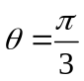 and 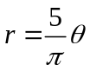 for 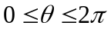 are drawn below
B
A
o
o

(a) Write down the polar coordinates of

(i) Point A (1 mark) (1 mark)

(ii) Point B (1 mark) (1)

(b) Find the EXACT distance between A and B. (2 marks) (1 mark)

Question 2 (7 marks)

Determine 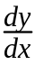 for each of the following. Do not simplify your answers

(a) 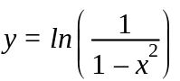 (2 marks)

(b) 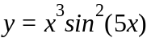 (2 marks)

(c) 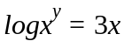 (3 marks)

Question 3 (7 marks)

Determine the following indefinite integrals.

(a) 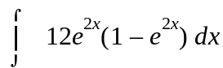 (2 marks)

(b) 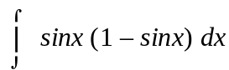 (3 marks)

(c) 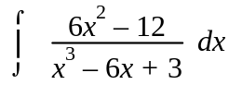 (2 marks)

Question 4 (7 marks)

(a) Find the exact value of the definite integral below:

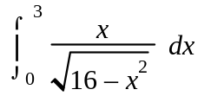 Use the substitution 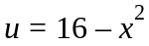 (4 marks)

(b) Show that 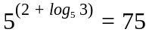 (3 marks)

Question 5 (4 marks)

Determine the area bounded by the curves 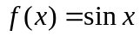 and 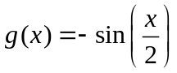 for
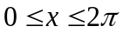.

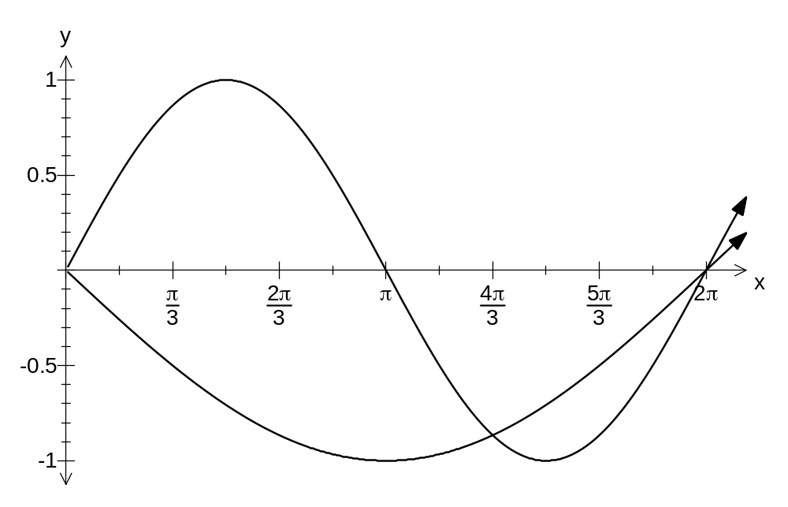

Question 6 (6 marks)

(a) Find 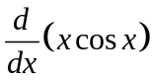, showing full working. (2 marks)

(b) Hence, evaluate the following definite integrals, giving exact values.

(i) 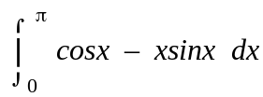 (2 marks) (1 mark)

(ii) 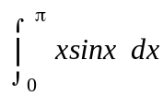 (2 marks) (1 mark)

Additional working space
Question number:

Additional working space
Question number:

Additional working space
Question number:

Additional working space
Question number:

